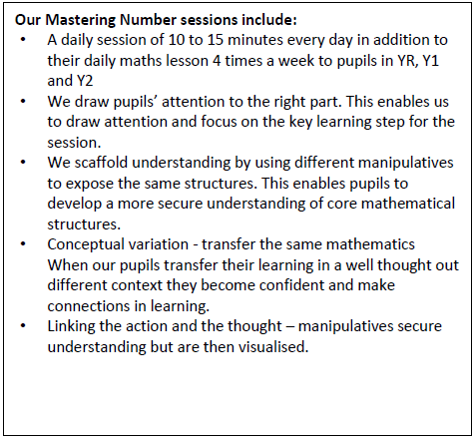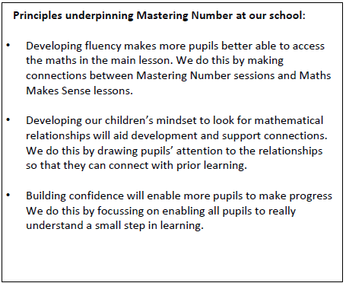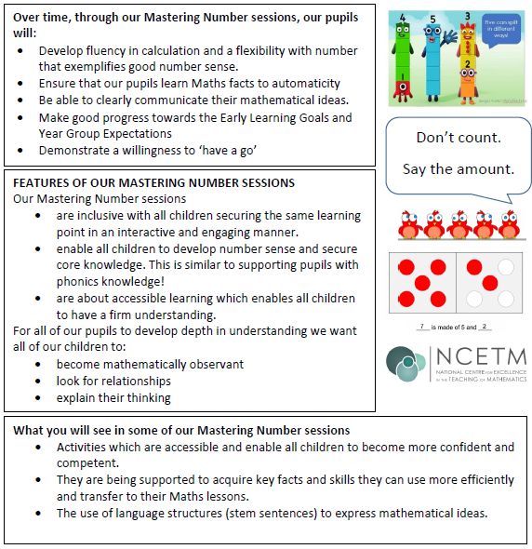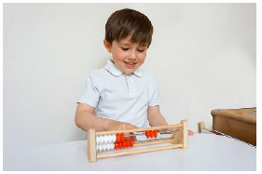Mastering Number at Nova Primary School

**At Nova Primary, we are actively participating in the NCETM Mastering Number Programme, following work within our local Maths Hub.**

**Reception Teacher: Miss Everson Year 1 Teacher: Mrs Kirke Year 2 Teacher: Miss Lauezzari**

**Maths Leaders: Mr Deeney & Mrs Brocklebank**