How we teach Times Tables at Nova

Smaller Factor First Method
- 5 mins, twice daily from Y3 T3 to Y4 T6. Minimum of 8 x a week.
- All pupils chant following the counting stick on the board (see image 1 below)
- Chanting recommendations:
Always say the smaller factor first
2 x 3 = 6 would be chanted as ‘two threes are six’
3 x 2 = 6 would be chanted as ‘two threes are six’
6 ÷ 2 = 3 would be chanted as Teacher ‘six divided by 2 is’, pupils reply ‘two threes are six’
- The counting stick is left on the board for pupils to refer to during the 2 minute test
- A timer is left up on the board so pupils can record how long the 40 questions took them. This time challenge allows pupils who find this easy to challenge themselves
- Pupils and teachers chant the times tables together to mark – Teacher questioning and children answering. Children answer division questions by answering with the multiplication fact
- At the end of the test, the pupils write their scores onto their papers and call out their scores for the teacher to keep a note of in spreadsheet or markbook
- Only move onto a new times tables booklet when less than 10% of the cohort are not getting full marks.
- Precision teach the facts, using a display board similar to image 2 , and conferencing cards
- Pay attention to the details of when new facts are being introduced –eg consider only moving onto test 5 when the initial facts are secure for 90% of the class. (see image 3 below)
- If pupils are not keeping up, review the overview. It is better to go slowly and keep the class together than to race ahead. The Y4 check point is exactly that – a checkpoint. If pupils are not ready for the test, but are secure in nearly all their times tables that may be better than a few of them being fully ready for the test!
- Potential consolidation activities are found at NCETM PD materials https://www.ncetm.org.uk/teaching-for-mastery/mastery-materials/primary-mastery-professional-development/
Image 1
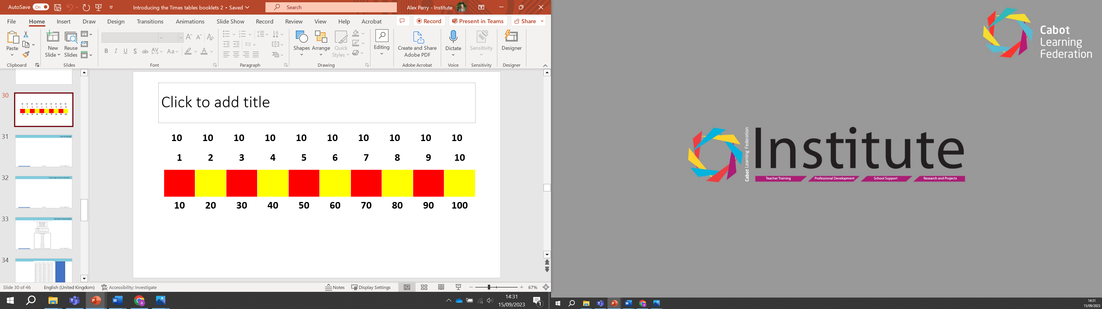

Image 2
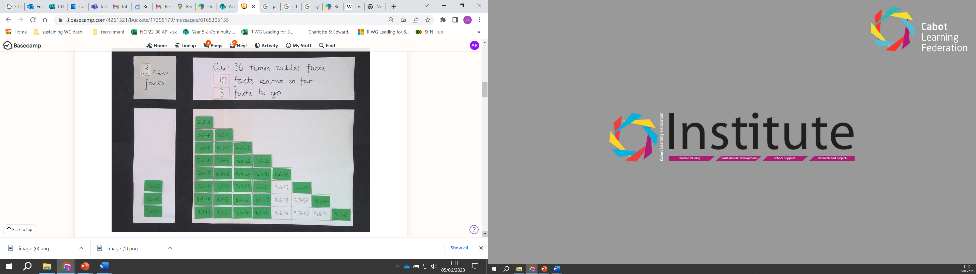
Image 3
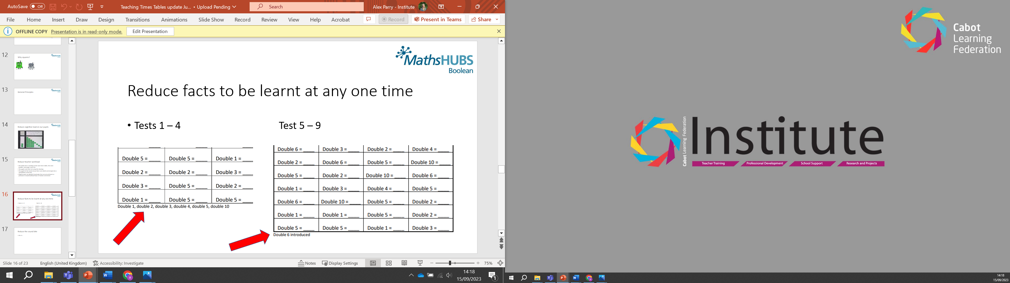

The joy of this programme is the slow way the facts are built up, allowing time for pupils to acquire a few facts at a time and keeping the cohort together.

Two-year programme
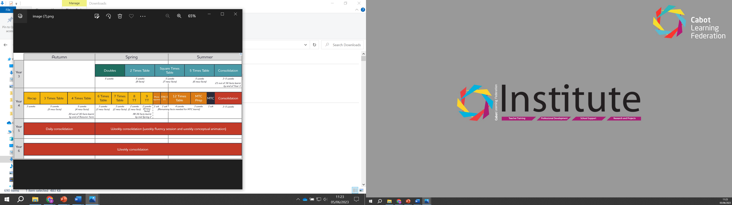

Potential one year programme
Y4 Terms 1 and 2 | Doubles, 2 x, Square
Terms 3 and 4 | 5x, 3x, 4x
Terms 5 and 6 | 6x, 7x + a couple of extra facts – 8x9, 11x11, 11x12 and 12 x12. Allow 3 weeks for pupils to transfer their knowledge onto a computer in time for
Y5 Terms 1 and 2

