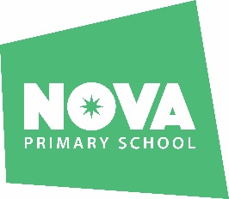

**Geography subject intent:**

* To inspire children’s curiosity and fascinations about the world and its people.
* For children to gain a knowledge of diverse places, people, resources and natural and human environments, together with an understanding of Earth’s key physical and human features
* To encourage children to collect, analyse and interpret a range of sources of geographical information, including data gathered through experiences of fieldwork, and to communicate their findings in a variety of ways.

**How we support the needs of *our* children through teaching Geography:**

* **Experiential learning -** Children have opportunities to learn geographical knowledge and skills through experiences of fieldwork at least once a year as well as through curriculum focused school events.
* **Social skills –** Children learn how to collect, analyse, interpret and communicate their learning through structured interactions with others.
* **Self-esteem -** Children learn that all opinions are valid and that their voice matters.
* **Resilience -** Children collect, analyse, interpret and communicate their learning in different ways to ensure they are not limited by their writing ability.
* **Cultural understanding –** As facilitated our Geography curriculum, children learn about Earth’s key physical and human processes including diverse places, people, resources and natural and human environments.
* **General knowledge –** As facilitated our Geography curriculum, children learn about Earth’s key physical and human processes including diverse places, people, resources and natural and human environments.
* **Oracy skills –**Children listen to and build on others’ ideas through structured discussions and partner talk when collecting, analysing, interpreting and communicate their learning.

**How do we teach Geography at Nova Primary?**

The geography curriculum at Nova Primary School aims to inspire, in all pupils, a lifelong curiosity and fascination for the world and all who inhabit it. Pupils are encouraged to view themselves as global citizens, consider their impact on Earth and innovate sustainable solutions for the future.

In EYFS, pupils develop their understanding of the physical world and the communities around them through a balance of high-quality continuous provision and planned experiences.

In Key Stage 1 and Key Stage 2, pupils embody the state of ‘being a geographer’ through an **enquiry-based approach**. This inclusive approach facilitates meaningful opportunities for pupils to engage in the geography enquiry process - question, gather data, reflect, communicate and evaluate. It fosters opportunities to challenge pupils’ high-order thinking and problems solving skills.

Using the National Curriculum, our pupils investigate big line of enquiry questions such as, “Why should we care about the environment?” and “How did the Earth evolve?”. With Nova’s clearly mapped geography progression, pupils’ knowledge, skills and vocabulary broadens and deepens throughout their education in the realms of locational knowledge, place knowledge, physical and human features and geographical skills and fieldwork.

Pupils in EYFS showcase their learning in a Learning Journal. Those in Key Stage 1 and Key Stage 2, record their journey in a Line of Enquiry book using a variety of presentation methods.

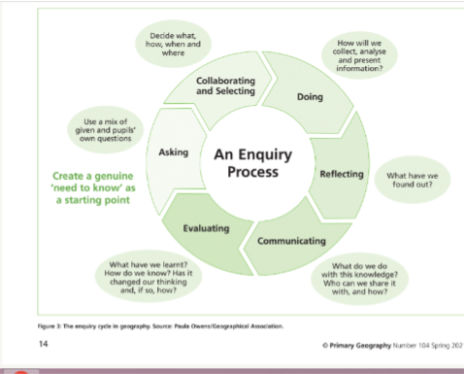

|  |  |  |  |  |
| --- | --- | --- | --- | --- |
|  | | | | |
|  |  |  |  |  |

**How do we assess Geography at Nova Primary?**

**Assessment of knowledge:**

At Nova, pupil’s geography knowledge, skills and understanding is assessed through formative assessments, summative assessments and pupil reflection.

**Formative assessments** show what children know and enables teachers to identify gaps and misconceptions to inform future learning opportunities. In practice, formative assessments may include mini-quizzes, ‘four from before’ recaps and knowledge trees reviews.

**Summative assessments** show what children have learned within a geography unit of teaching and enables teachers to identify gaps and misconceptions to inform future learning opportunities. In practice, summative assessments may include learning journey maps and end of unit quizzes.

**Pupil reflections** allow children to reflect what they have learned as geographers. In practice, this may include the ‘curriculum character’ used to guide children’s personal reflections on their engagement in the geographical enquiry process. Children are given the opportunity to share their learning by adding to their Line of Enquiry reflection page weekly.