How have the ancient Greeks influenced us?
L earning Journey
E ngaging
A uthentic
R igorous
N ova Curriculum
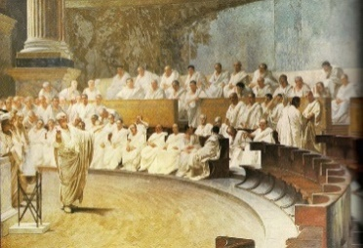
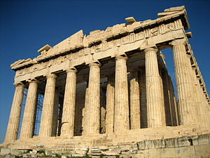
Year 5 | Terms 3 & 4 | Big concept: Changes over time & legacy
Overview:
This enquiry enables learners to consider Daily life for the ancient Greeks and how there are aspects of our own lives which are shaped by the ancient Greeks. Children will develop as geographers throughout this unit by using map skills to locate Greece and where it is in relation to Bristol. Children will also describe the geographical similarities and differences of a region of the UK and a European country.

Class texts have been chosen to enrich children’s learning, encouraging them to make links with their reading and wider curriculum learning. This term our class novel is Malamander by Thomas Taylor. An exciting visit to the town of ‘Eerie on sea’ and discovering the unctuous Malamander creep.

Learning links (previous learning): |  | Celebrating diversity and inspirational People:
In year 4, children will have already explored the Roman settlement within the UK.  Geography: locational and place knowledge of continents and oceans. |  | To discover how the Olympics that were celebrated by the ancient Greeks compare to the Olympics of today.
Launch and Landings |  | Experiential learning opportunities:
Launch: create Greek key designs vases to decorate classroom developing on printing skills from Term 2.  Landing: Children create a zigzag book to showcase the information about Greek mythology they have learnt |  | Research, design, make and evaluate different recipes – using pitta bread and Greek ingredients.  Class assembly for parents and carers.
NC Objectives – Skills, knowledge and vocabulary taught through Line of Enquiry
History: | DT – Cam Mechanisms
As Historians we will learn about.  - Learn about how Ancient Greeks have influenced us through democracy.  - Comparison of life in ancient Greece and life today.  - Investigate how Ancient Greeks have influenced the food we eat.  - develop a chronologically secure knowledge of history: Time period studied (when did the ancient Greeks live?) | As Designers and Engineers we will  - Understand and use mechanical structures in their products e.g Cam mechanisms  - Join materials using appropriate methods.  - Use a hand drill to drill tight and loose fit holes.  - Justify their decisions about materials and methods of construction.  - Evaluate and refine designs.
Geography | Art:
As Geographers we will:  - Use geographical skills to locate Greece and comment on the differences between the geography in the UK and Greece.  - Identify and describe three major climate zones (e.g. tropical, temperate, polar).  - Identify the equator, northern and southern hemispheres, Tropics of Cancer/ Capricorn, Arctic/ Antarctic Circle | As Artists we will:  - Give detailed observations about a notable artist using collagraph print  - Experiment with collagraph printing techniques.  - Experiment with Hapa-Zome printing techniques using a variety of tools  - Give detailed observations about a notable artist using lino print  - Create accurate repeating patterns using lino printing.

Opportunities for core subject learning across the curriculum
As readers and writers we will: | As mathematicians we will:
As Writers we will be writing:  Fiction Narrative Elf Wood: Focus on setting  Non-fiction : Persuasion. Final piece to persuade people to visit/live in Eerie on Sea.  Fiction Narrative: Trapped (Characterisation)  Non fiction recount: My close call  As Readers:  Shared Text: Malamader  Non Fiction Text: Elf Wood  Text Types: Viking sagas, non-chronological reports, first person recount  Cross curricular writing in LOE books: persuasion to visit the town of Cheerie on sea. | As Mathematicians we will developing our understanding of:  - Multiplication and division  - Fractions  - Decimals and percentages.
Discrete subject teaching - Skills, knowledge and vocabulary taught discretely
Physical Education | Music
As fit and healthy citizens we will develop skills in:  - Yoga  - archery (Progressive sports)  - basketball  - dance (progressive sports) | As Musicians we will develop our musical skills and knowledge through Beacon Bristol music scheme:  - Composition – Unit Air
Computing | PSHE
In computing we will develop skills through Teach Computing scheme:  - Video Editing (T3)  - databases | As fit and healthy citizens we will develop our knowledge through SCARF scheme:  - Keeping myself safe  - Me and my responsibilities.
RE | Science (taught through PPA):
As philosophers we will explore the question:  What would Jesus do and can we live by the values of Jesus in the 21st Century? | - Forces (air and water resistance)  - Working scientifically.

