Overview of Phonics Content
Phase 2
Sound | Picture | Action | Non-Cursive Rhyme | Cursive Rhyme
s | 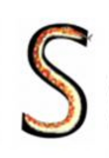 | Weave hand in an s shape, like a snake, and say ssssss. | Slither down the snake | Lead in, slither down the snake, lead out
a | 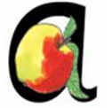 | Wiggle fingers above elbow as if ants crawling on you, saying a, a, a | Around the apple, down the leaf | Lead in, around the apple, down the leaf, lead out
t | 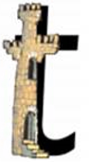 | Turn head from side to side as if watching tennis and say t, t, t, t | Down the tower, across the tower | Lead in, down the tower, across the tower, lead out
p | 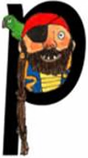 | Pretend to be a mouse by wriggling fingers at end of noise and squeak i, i, i, i | Down the pirate’s plait and around his face | Lead in, down the pirate’s plait and around his face, lead out
i | 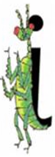 | Pretend to puff out candles and say p, p, p | Down the insect’s body and dot for his head | Lead in, down the insect’s body and dot for his head, lead out
n | 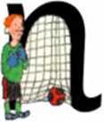 | Hold arms out at side, as if a plane, and say nnnnnnnnnn. | Down Nobby and over his net | Lead in, down Nobby and over his net, lead out
m | 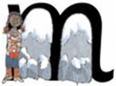 | Rub tummy as if seeing tasty food and say mmmmmm | Down Maisie, Mountain, Mountain | Lead in, down Maisie, Mountain, Mountain, lead out
d | 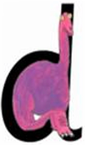 | Beat hands up and down as if playing a drum and say d, d, d, d | Around the dinosaur’s bottom, up his tall neck and down to his toes | Lead in, around the dinosaur’s bottom, up his tall neck and down to his toes, lead out
g | 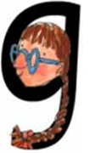 | Spiral hand down, as if water going down the drain, and say g, g, g | Around the girl’s face, down her hair and give her a curl | Lead in, around the girl’s face, down her hair and give her a curl, lead out
o | 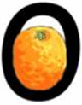 | Pretend to turn light switch on and off and say o, o, o, o. | All around the orange | Lead in, all around the orange, lead out
c | 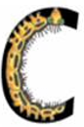 | Raise hands and snap fingers as if playing castanets and say ck, ck, ck | Curl around the caterpillar | Lead in, curl around the caterpillar, lead out
k | 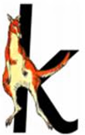 | Raise hands and snap fingers as if playing castanets and say ck, ck, ck | Down the kangaroo’s body, kick out for his tail, kick out for his leg | Lead in, down the kangaroo’s body, loop for the tail and flick for the leg
ck |  | Raise hands and snap fingers as if playing castanets and say ck, ck, ck
e | 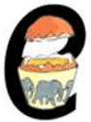 | e Pretend to tap an egg on the side of a pan and crack it into the pan, saying eh, eh, eh | Lift off the top and scoop out the egg | Lead in, lift off the top and scoop out the egg, lead out
u | 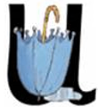 | Pretend to be putting up an umbrella and say u, u, u, u | Down and under, up to the top and draw the puddle | Lead in, down and under, up to the top and draw the puddle, lead out
r | 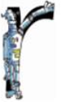 | Pretend to be a puppy holding a rag, shaking head from side to side and say rrrrrrrrrrr. | Down the robot’s back and curl over his arm | Lead in, down the robot’s back and curl over his arm, lead out
h | 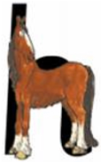 | Hold hand in front of mouth panting h, h, h as if you are out of breath | Down the head, to his hooves and over his back | Lead in, down the head, to his hooves and over his back, lead out
b | 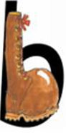 | Pretend to hit a ball with a bat and say b, b, b, b. | Down the laces, to the heel and around the toe | Lead in, down the laces, to the heel and around the toe, lead out
f | 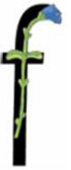 | Let hands gently come together as if toy fish deflating, and say ffffff. | Down the stem and draw the leaves | Lead in, loop around the flower, down the stem and loop for the leaves, lead out
ff
l | 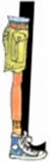 | Pretend to lick a lollipop and say l, l, l, l | Down the long leg | Lead in, down the long leg, lead out
ll
ss
Phase 3
Sound | Picture | Action | Non-Cursive Rhyme | Cursive Rhyme
j |  | Pretend to wobble on a plate and say j, j, j | Down his body, curl, and dot for his head | Lead in, down his body and loop. Dot for the head
v | 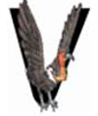 | Pretend to be holding the steering wheel of a van and say vvvvvvvv. | Down a wing, up a wing | Lead in, down a wing, up a wing, lead out
w | 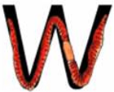 | Blow on to open hand, as if you are the wind, and say wh, wh, wh. | Wiggle down, up, down, up | Lead in, wiggle down, up, down, up, lead out
x | 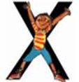 | Pretend to take an x-ray with an x-ray camera, saying ks, ks, ks | Down the arm and leg, up the leg and other arm and down the other leg | Lead in, down the arm and leg, up the leg and other arm and down the other leg
y | 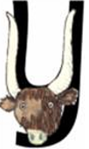 | Pretend to be eating a yoghurt and say y, y, y. | Down a horn, up a horn and under his head | Lead in, down a horn, up a horn and loop under his head
z | 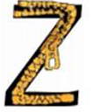 | Put arms out at sides and pretend to be a bee, saying zzzzzzzzzz. | Zig-zag-zig | Lead in, zig-zag-zig, lead out
zz
qu | 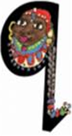 | Make a duck´s beak with your hands and say qu, qu, qu | Round her head, up past her earring, down her hair, and flick | Lead in, round her head, up past her earring, down her hair, and flick
ch |  | Move arms at sides as if you are a train, saying ch, ch, ch.
sh |  | Place index finger over lips and say sh sh sh.
th |  | Pretend to be naughty clowns and stick out tongue a little

Sound | Picture | Action | Ditty
ng | 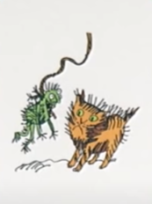 | Imagine you are a weightlifter and pretend to lift a heavy weight above your head saying ng | A thing on a string
ai | 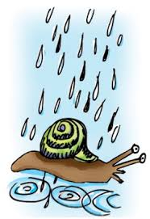 | Raining fingers | Snail in the rain
ee | 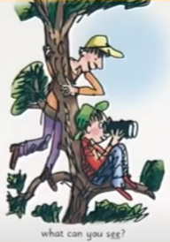 | Look through binocular fingers | What can you see?
igh | 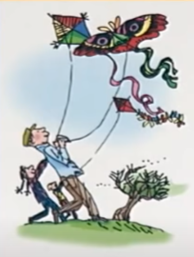 | Hold your hand high in the air | Fly high
oa | 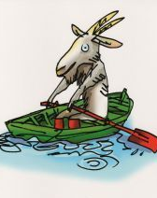 | Pretend to row a boat | Goat in a boat
oo | 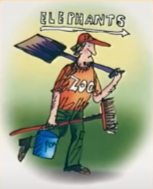 | Hold your nose | Poo at the zoo
oo | 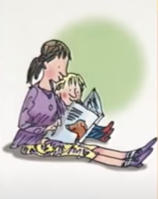 | Make hands into a book and open and close | Look at a book
ar | 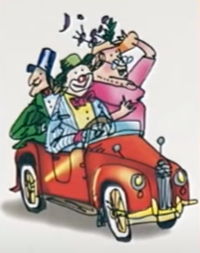 | Turn the key with your hands | Start the car
or | 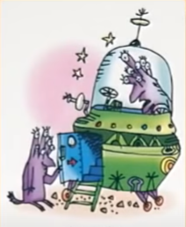 | Pretend to push a door closed | Shut the door
ur | 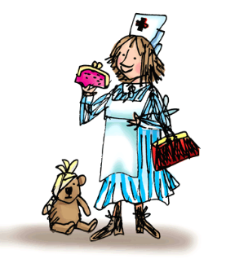 | Pretend to open a purse | Nurse with a purse
ow | 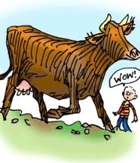 |  | Brown cow
oi | 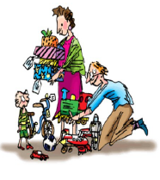 | Point and say oi | Spoil the boy
ear | 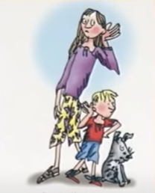 | Hand to ear | Hear with your ear
air | 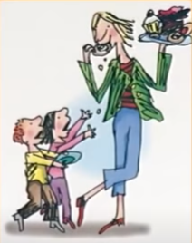 | Hands on hips | That’s not fair
ure | 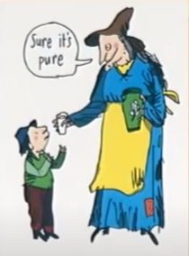 |  | Sure it’s pure
er | 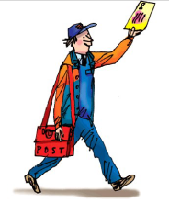 | Pretend to wave a letter in the air | Better Letter

Phase 5
Sound | Picture | Ditty
ay |  | May I play?
ou |  | Shout it out
ie | 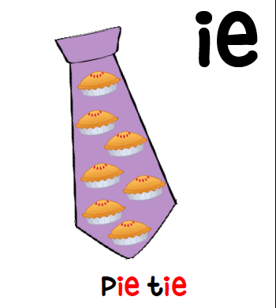 | Fly tie
ea |  | Cup of tea
oy |  | Toy for a boy
ir |  | Whirl and twirl
ue | 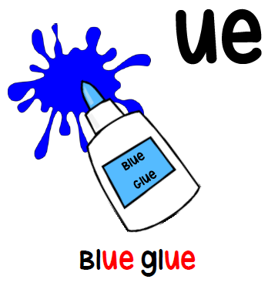 | Blue glue
aw | 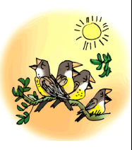 | Yawn at dawn
wh | 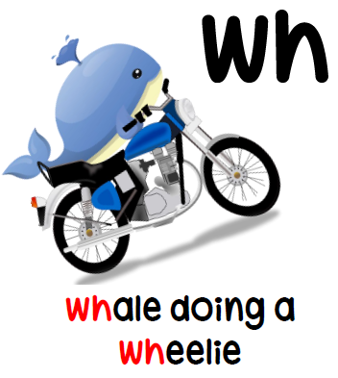 | Whale doing a wheelie
ph | 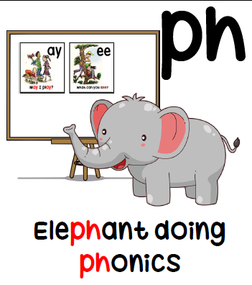 | Elephant doing phonics
ew | 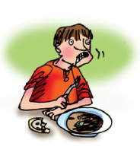 | Chew the stew
oe | 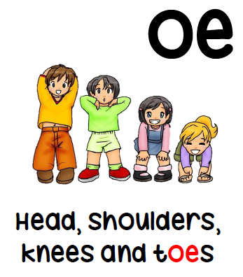 | Head, shoulders, knees and toes
au |  | 5, 4,3,2,1...Launch!
a-e | 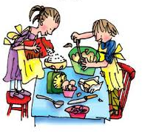 | Make a cake
e-e | 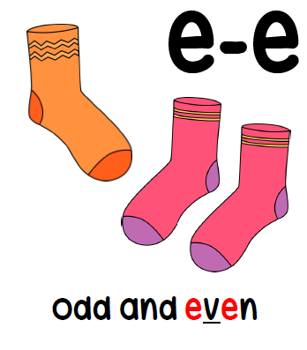 | Odd and even
i-e | 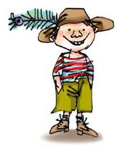 | Nice smile
o-e | 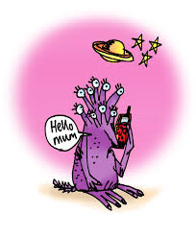 | Phone home
u-e | 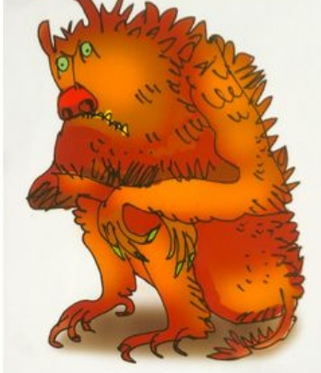 | Huge brute

ey | 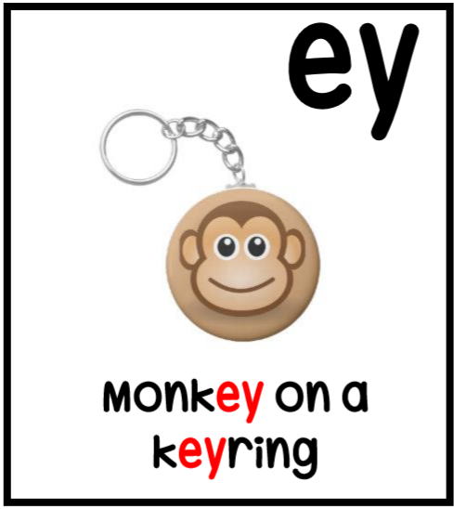 | Money on a key ring

Alternative pronunciations
Sound | Picture | Ditty
i |  | island
o |  | O.K.
c |  | circle
g |  | Geraldine the Giraffe
u |  | unicorn
ow | 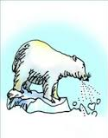 | Blow the snow
ie | 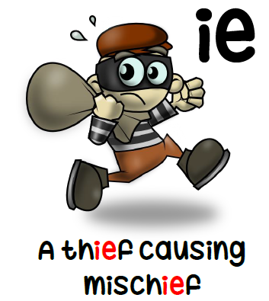 | A thief causing mischief
ea
er
a |  | alien
y | 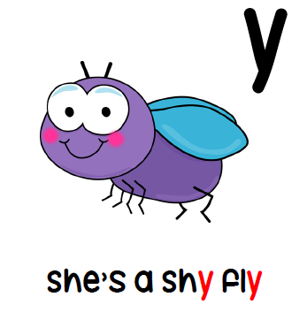 | She’s a shy fly
ch
ou

